Programming Fundamentals

2nd semester, Spring 2018
FAROOQ AHMAD
17L-4407
EE-2A
Lab Report # 1

INTRODUCTION
In this first lab session of the course, we revised the concepts and ideas of the previous course Introduction To Computing. We revised the use of static arrays, loops, file handling and functions. Static arrays are used to handle a set of values at the same time. Files make it easier to transfer and use data.

OBJECTIVE
The course learning objective of this lab session was
- Revision of compiler.
- Revision of static arrays.
- Revision of filing.

PROCEDURE
The in lab tasks of this lab session includes two exercises …
Exercise 1
Code:
#include <iostream>
using namespace std;

void selectionsort(int a[],int size)
{
for (int i = 0; i < size; i++)
{
for (int j = i + 1; j < size; j++)
{
if (a[i]>a[j])
swap(a[i], a[j]);
}
}
}

void InputElements(int a[],int size)
{
for (int loop = 0; loop < size; loop++)
{
cout << "Enter " << loop + 1 << " Element : ";
cin >> a[loop];
}
}

void display(int a[], int size)
{
for (int loop = 0; loop < size; loop++)
{
cout << a[loop]<<" ";
}
cout << endl;
}

int main()
{
int a[10];

InputElements(a, 10);
selectionsort(a, 10);
display(a, 10);

system("pause");
return 0;
}
Exercise 2:
Code:
#include <iostream>
#include <fstream>
using namespace std;

void Display(char firstName[5][10], char secondName[5][10], int scores[5], char grades[5])
{
for (int i = 0; i < 5; i++)
{
cout << firstName[i] << " ";
cout << secondName[i] << " ";
cout << scores[i] << " ";
cout << grades[i] << endl;
}
}

void DisplayHighest(char firstName[5][10], char secondName[5][10], int scores[5], char grades[5], int Highest)
{
cout << endl << "Highest Scorers Are : " << endl << endl;
for (int i = 0; i < 5; i++)
{
if (scores[i] == Highest)
{
cout << firstName[i] << " ";
cout << secondName[i] << " ";
cout << scores[i] << " ";
cout << grades[i] << endl;
}
}
cout << endl;
}

void ReadAndFindMax(char firstName[5][10], char secondName[5][10], int scores[5], char grades[5], int &Highest)
{
int loop = 0;

ifstream read;
read.open("students.txt");
while (!read.eof())
{
read >> firstName[loop];
read >> secondName[loop];
read >> scores[loop];
read >> grades[loop];
if (scores[loop] > Highest)
Highest = scores[loop];
loop++;
}

}

int main()
{
char firstName[5][10];
char secondName[5][10];
int scores[5];
char grades[5];

int Highest = 0;

ReadAndFindMax(firstName, secondName, scores, grades, Highest);
Display(firstName, secondName, scores, grades);
DisplayHighest(firstName, secondName, scores, grades, Highest);

system("pause");
return 0;
}

ISSUES
Multiple issues were faced while recalling the previous concepts, syntax, and logics of the course introduction to computing which were resolved after revising the entire course of itc.

CONCLUSION
C++ Basic can be used for a number of different operations and perform different tasks on the data. That data can be read from and stored in a group from a file. The arrays can be sorted and swapped.

APPLICATION

The usage of arrays and functions makes the code very compact and easier, making the program more effective to alter and handle.

POST LAB
Code:
Question 1:
#include <iostream>
using namespace std;
int main()
{
double a[10], sum = 0;
double avg[6];
cout << "Enter 10 values: ";
for (int i = 0; i < 10; i++)
{
cin >> a[i];
}

int b = 0;
for (int j = 0; j + 4 != 10; j++)
{
b = j;
sum = 0;
for (int i = 0; i < 5; i++,b++)
{
sum = sum + a[b];
}
avg[j] = (sum / 5);
}

cout << "Average : ";
for (int i = 0; i < 6; i++)
{
cout << avg[i]<<" ";
}
cout << endl;

return 0;
}
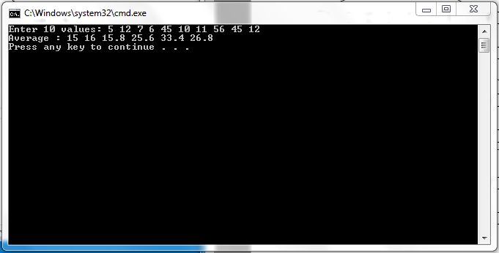
Question 2:
#include<iostream>
using namespace std;

int main()
{
int a,b;
cout<<"Enter the two variables: ";
cin>>a>>b;
a=a+b;
b=a-b;
a=a-b;
cout<<"The swapped variables are: ";
cout<<a<<" "<<b<<endl;

return 0;
}
